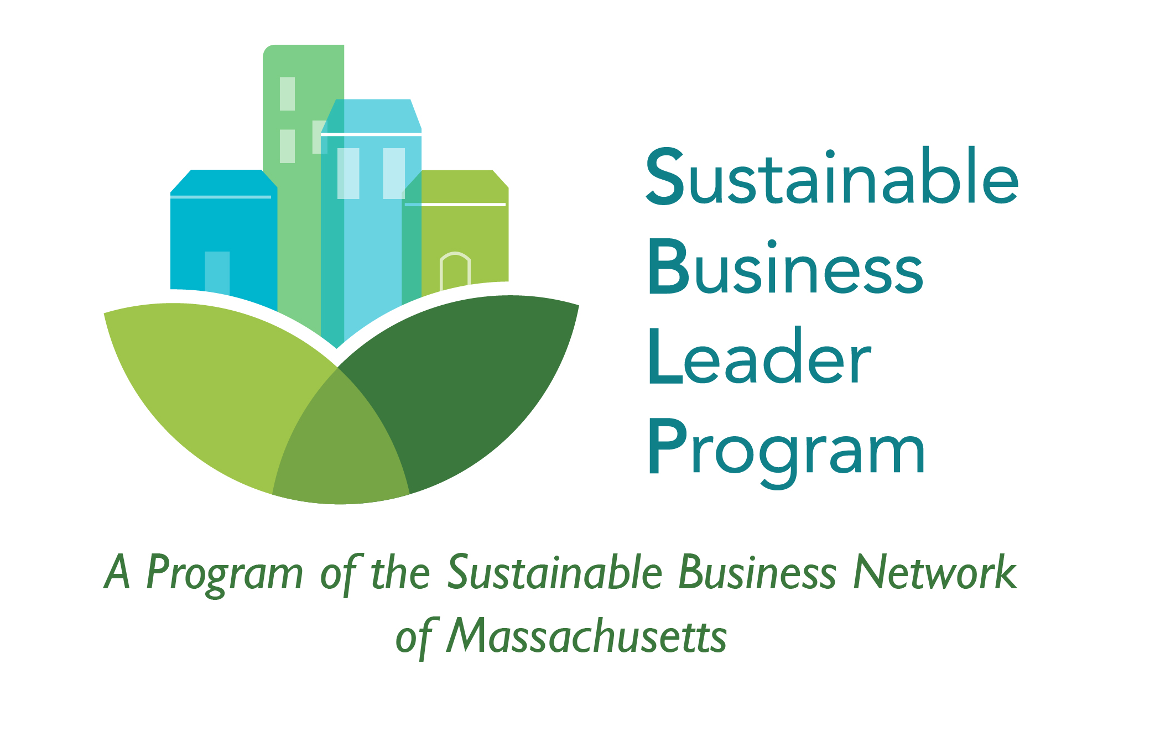

Sustainable Business Leader Program

- Sustainability Assessment Form (SAF) -

SBLP Primary Coordinator: Rachel Wencek

wencekrm@gmail.com

sustainablebusinessleader.org

Please Complete:
Date
Business Name
Address/Phone number
Business Owner
Building Owner/
Property Manager
Green Team Leader/
Members

How to Complete the Form

The Sustainability Assessment Form has 113 questions. In the right-hand columns, mark the appropriate percentage, N/A (Not Applicable), or Yes/No to indicate 100% usage or non-usage. If unsure, do not make a selection and indicate “Not sure” in the Notes column.

Example:
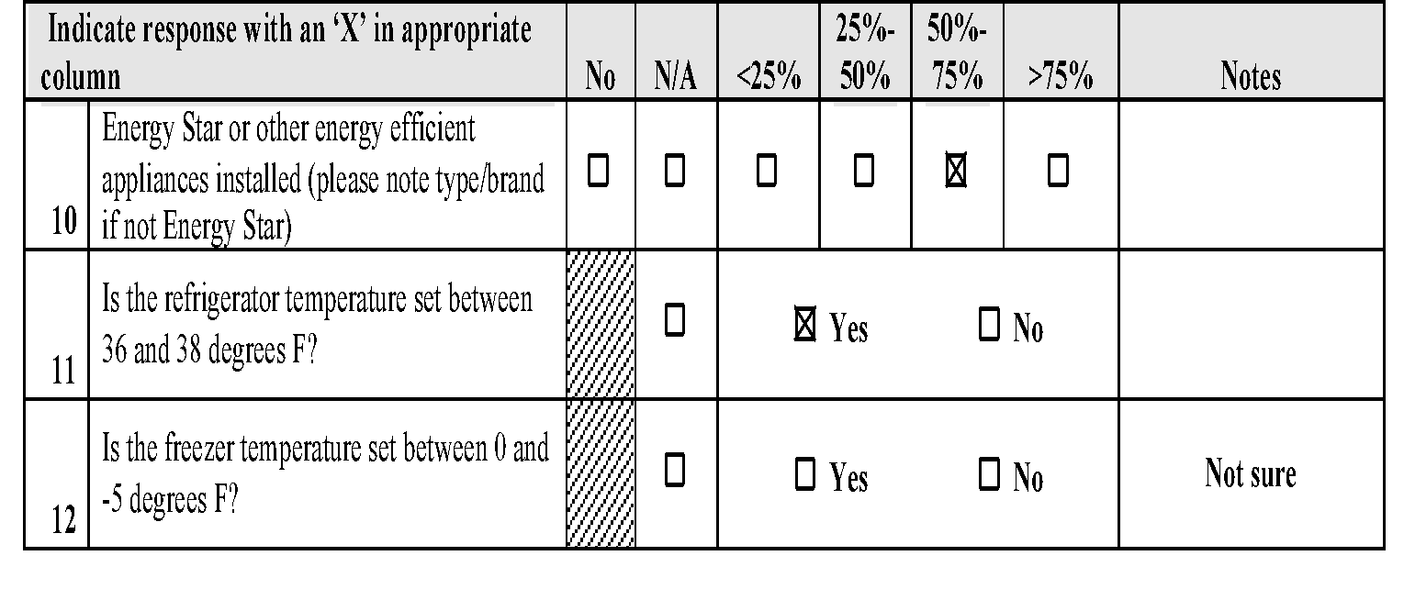
- For #10 below, if between 50% and 75% of appliances are certified Energy Star or otherwise energy efficient, select the box under 50%-75% and note as is appropriate.
- For #11 below, if all refrigerators are set between 35 and 38 degrees F, select YES.
- For #12 below, if you are unsure of the freezer temperature settings, leave blank and indicate “Not sure” in the Notes column.

Please Note: This form is meant to be a checklist that will inform recommendations for your company and is not a rating system for evaluation. Additionally, a glossary has been provided at the end of this document for your reference.
1. ENERGY EFFICIENCY

Lighting
Indicate response with an ‘X’ in appropriate column |  | No | N/A | <25% | 25%-50% | 50%-75% | >75% | Notes
1 | Screw-in bulbs that are energy-saving LEDs | ☐ | ☐ | ☐ | ☐ | ☐ | ☐
2 | Tube lighting are all LED, not fluorescent | ☐ | ☐ | ☐ | ☐ | ☐ | ☐
3 | Interior common areas & rooms with occupancy and/or light sensors | ☐ | ☐ | ☐ | ☐ | ☐ | ☐
4 | Exterior lights with timers or photocells | ☐ | ☐ | ☐ | ☐ | ☐ | ☐
5 | Interior workspace arranged to take advantage of areas with natural light (If yes, please describe in notes column) | ☐ | ☐ | ☐ | ☐ | ☐ | ☐
6 | Shades & awnings used to adjust light and to reduce heat in summer/ heat loss in winter. | ☐ | ☐ | ☐ | ☐ | ☐ | ☐
7 | Summertime policy to keep the lights turned off when sufficient natural light is available, similar policies for winter.
Appliances
Indicate response with an ‘X’ in appropriate column |  | No | N/A | <25% | 25%-50% | 50%-75% | >75% | Notes
8 | Appropriate office equipment turned off when not in use. | ☐ | ☐ | ☐ | ☐ | ☐ | ☐
9 | Energy Star or other energy efficient appliances installed (please note type/brand if not Energy Star). | ☐ | ☐ | ☐ | ☐ | ☐ | ☐
10 | Is the refrigerator temperature set between 36 and 38 degrees F? Or a similar narrow range. | ☐ | ☐ | ☐ Yes ☐ No
11 | Is the freezer temperature set between 0 and -5 degrees F? Or set recommended. | ☐ | ☐ | ☐ Yes ☐ No
12 | Have appliances been maintained during the past year (i.e., filters/coils vacuumed, fans and seals in good condition)? | ☐ | ☐ | ☐ Yes ☐ No
13 | “Smart” variable speed hood fans used (commercial kitchens only). | ☐ | ☐ | ☐ | ☐ | ☐ | ☐
14 | Vending machines w/ occupancy sensors that reduce power requirements during periods of inactivity (include approx. #) | ☐ | ☐ | ☐ | ☐ | ☐ | ☐
15 | Power strips used to turn off Phantom loads (see glossary) | ☐ | ☐ | ☐ | ☐ | ☐ | ☐
Hot Water
Indicate response with an ‘X’ in appropriate column |  | No | N/A | <25% | 25%-50% | 50%-75% | >75% | Notes
16 | Is the water temperature 120 degrees F, or a set temperature for maximum efficiency? | ☐ | ☐ | ☐ Yes ☐ No
17 | Water heaters installed with an insulating blanket (READ LABEL. Most installed after year 2000 do NOT need one). | ☐ | ☐ | ☐ | ☐ | ☐ | ☐
18 | Hot water supply pipes wrapped with pipe insulation especially in unconditioned space | ☐ | ☐ | ☐ | ☐ | ☐ | ☐

HVAC
Indicate response with an ‘X’ in appropriate column |  | No | N/A | <25% | 25%-50% | 50%-75% | >75% | Notes
19 | Is the room thermostat set at 76 degrees F or above for cooling? Or consistent temperature based on need? | ☐ | ☐ | ☐ Yes ☐ No
20 | Is the room thermostat set at 68 degrees F or below for heating? Or consistent temperature based on need? | ☐ | ☐ | ☐ Yes ☐ No
21 | Are there programmable thermostats to turn HVAC down after hours? | ☐ | ☐ | ☐ Yes ☐ No
22 | Heating & ventilation system maintained or evaluated for energy efficiency within the last year. | ☐ | ☐ | ☐ Yes ☐ No
23 | Central air conditioning units with variable air volume (VAV) systems or air conditioning units with Seasonal Energy Efficient Rating (SEER) greater than 13. | ☐ | ☐ | ☐ Yes ☐ No
24 | Rooms with ceiling fans or floor fans to promote air circulation & reduce the need for heating & cooling. | ☐ | ☐ | ☐ | ☐ | ☐ | ☐
Building Envelope
Indicate response with an ‘X’ in appropriate column |  | No | N/A | <25% | 25%-50% | 50%-75% | >75% | Notes
25 | Is the building fully insulated? | ☐ | ☐ | ☐ Yes ☐ No
26 | Double pane windows | ☐ | ☐ | ☐ | ☐ | ☐ | ☐
27 | Weather stripping (weatherizing and caulking) to seal around windows & doors to close air gaps | ☐ | ☐ | ☐ | ☐ | ☐ | ☐
Renewable Energy
Indicate response with an ‘X’ in appropriate column |  | No | N/A | <25% | 25%-50% | 50%-75% | >75% | Notes
28 | Do you have any solar water heaters installed or have you invested in other renewable energy options like geothermal, photovoltaic, wind? (If yes, please specify in notes column) | ☐ | ☐ | ☐ Yes ☐ No
29 | Do you invest in Green Up or a green program through your electricity provider (Nat'l Grid or Eversource)? | ☐ | ☐ | ☐ Yes ☐ No
Comments:

2. WATER CONSERVATION

Water Appliances
Indicate response with an ‘X’ in appropriate column |  | No | N/A | <25% | 25%-50% | 50%-75% | >75% | Notes
30 | Toilets with ultra-high efficiency not exceeding 1.6 gpf | ☐ | ☐ | ☐ | ☐ | ☐ | ☐
31 | Urinals with ultra-low-flow (not exceeding 0.5 gpf flush) or that are waterless | ☐ | ☐ | ☐ | ☐ | ☐ | ☐
32 | Lavatory sinks with low flow aerators not exceeding 1.5 gpm | ☐ | ☐ | ☐ | ☐ | ☐ | ☐
33 | Low flow, self-closing faucets, either infrared or spring loaded | ☐ | ☐ | ☐ | ☐ | ☐ | ☐
34 | Kitchen sinks with low flow aerators not exceeding 1.5 gpm | ☐ | ☐ | ☐ | ☐ | ☐ | ☐
35 | Showerheads not exceeding 1.8 gpm | ☐ | ☐ | ☐ | ☐ | ☐ | ☐
36 | Rainwater collection system for outdoor landscaping or other use (If yes, please specify in notes column) | ☐ | ☐ | ☐ Yes ☐ No
gpf= gallons per flush, gpm= gallons per minute

Water Conservation Practices
Indicate response with an ‘X’ in appropriate column |  | No | N/A | <25% | 25%-50% | 50%-75% | >75% | Notes
37 | Are signs posted in restrooms & kitchen areas to encourage water conservation? | ☐ | ☐ | ☐ Yes ☐ No
38 | Have you checked plumbing for leaks within the past year (toilets, faucets, pipes, pumps)? | ☐ | ☐ | ☐ Yes ☐ No
39 | Landscaping practices that conserve water: minimal watering as needed, low-maintenance landscapes with native, perennial, drought-resistant plants | ☐ | ☐ | ☐ | ☐ | ☐ | ☐
Comments:

3. POLLUTION PREVENTION & SAFE ALTERNATIVES

Are your cleaners on-site staff? ☐ or contractors? ☐
Do you have a hazardous waste collection site/vendor? ☐ Yes No ☐
What is your hazardous waste procedure? Storage: ☐ Pick-up: ☐ Drop-off: ☐
Low-toxic cleaners used, brand names:

Pollution Prevention & Safe Alternatives
Indicate response with an ‘X’ in appropriate category |  | No | N/A | <25% | 25%-50% | 50%-75% | >75% | Notes
40 | Do you have a hazardous waste collection procedure (storage, pick-up, drop-off)? | ☐ | ☐ | ☐ Yes ☐ No |  |  | ☐
41 | Proper disposal for grease, oil, solvents, paint, unused cleaning chemicals, other chemicals | ☐ | ☐ | ☐ | ☐ | ☐ | ☐
42 | Proper disposal for spent fluorescent bulbs | ☐ | ☐ | ☐ | ☐ | ☐ | ☐
43 | Proper disposal of electronic equipment (computers, cell phones, etc.) | ☐ | ☐ | ☐ | ☐ | ☐ | ☐
44 | Use of low-toxic cleaners | ☐ | ☐ | ☐ | ☐ | ☐ | ☐
45 | Promotional materials printed with soy/low-VOC inks | ☐ | ☐ | ☐ | ☐ | ☐ | ☐
Comments:

4. TRANSPORTATION

Fleet
Indicate response with an ‘X’ in appropriate column |  |  | No |  | N/A |  | <25% | 25%-50% | 50%-75% | >75% | Notes
46 | Do you record the mileage of each vehicle? |  | ☐ |  | ☐ |  | ☐ Yes ☐ No
47 | Do you have a system to monitor the fuel efficiency of your vehicle(s) and routes? |  | ☐ |  | ☐ |  | ☐ Yes ☐ No
48 | Percentage of alternative vehicles and/or fuels (hybrid, biodiesel, CNG), bikes, etc utilized (Please indicate alternative types in notes column) |  | ☐ |  | ☐ |  | ☐ | ☐ | ☐ | ☐
49 | Vehicles that average more than 40mpg |  | ☐ |  | ☐ |  | ☐ | ☐ | ☐ | ☐
50 | Are there any anti-idling policies established for delivery vehicles (your own or external)? |  | ☐ |  | ☐ |  | ☐ Yes ☐ No
51 | Are deliveries making full load trips? |  | ☐ |  | ☐ |  | ☐ Yes ☐ No
52 | Are deliveries grouped to common locations/regions? |  | ☐ |  | ☐ |  | ☐ Yes ☐ No
53 | Do you utilize alternative car-sharing choices such as Zipcar, etc.? |  | ☐ |  | ☐ |  | ☐ Yes ☐ No
Employee Transportation
Indicate response with an ‘X’ in appropriate column |  | No |  | N/A |  | <25% |  | 25%-50% | 50%-75% | >75% | Notes
54 | Employees that take public transportation | ☐ |  | ☐ |  | ☐ |  | ☐ | ☐ | ☐
55 | Employees who walk or bike | ☐ |  | ☐ |  | ☐ |  | ☐ | ☐ | ☐
56 | Are employees given a subsidy or incentive (ex. MBTA pass subsidy, Bicycle Benefits membership) for taking public transportation or other alternative transportation? (If yes, please specify in notes column) | ☐ |  | ☐ |  | ☐ Yes ☐ No
57 | Are carpool matching services (Mass Rides or internal) offered that allow employees to find co-workers who live near them | ☐ |  | ☐ |  | ☐ Yes ☐ No
58 | Do you have a guaranteed/emergency ride home program in place for employees that use alternative transportation? | ☐ |  | ☐ |  | ☐ Yes ☐ No
59 | Is biking to work encouraged by providing bike racks/bike storage? | ☐ |  | ☐ |  | ☐ Yes ☐ No
60 | Is preferential parking available for employees that carpool? | ☐ |  | ☐ |  | ☐ Yes ☐ No
61 | Use of teleconferencing, Zoom, etc. in place of travel to conferences/meetings. | ☐ |  | ☐ |  |  | ☐ | ☐ | ☐ | ☐
62 | Are employees allowed to work remotely? (If yes, please describe remote work policy in notes column) | ☐ |  | ☐ |  |  | ☐ Yes ☐ No
Comments:

5. WASTE REDUCTION

Reduce
Indicate response with an ‘X’ in appropriate category |  | No | N/A | <25% | 25%-50% | 50%-75% | >75% | Notes
63 | Printers and Copiers set to 2-sided printing. If 1 sided printing required, please describe in notes. | ☐ | ☐ | ☐ | ☐ | ☐ | ☐
64 | E-Fax Software / Email / Digital used, when possible. | ☐ | ☐ | ☐ | ☐ | ☐ | ☐
65 |  | ☐ | ☐ | ☐ | ☐ | ☐ | ☐
66 | Writing or calling for removal from mailing list to reduce junk mail | ☐ | ☐ | ☐ | ☐ | ☐ | ☐
67 | Purging your own mailing list to eliminate duplicate mailings | ☐ | ☐ | ☐ | ☐ | ☐ | ☐
68 | Disposables eliminated by using permanent ware (bottles, cups, mugs, towels/rags, silverware). If using disposables for specific reasons, please note why (if okay to share). | ☐ | ☐ | ☐ | ☐ | ☐ | ☐
69 | Single-use bottled water used If yes, note why (if it cane be discussed.) | ☐ | ☐ | ☐ | ☐ | ☐ | ☐
70 | Refillable containers to avoid individual packets (i.e., sugar, salt & pepper) | ☐ | ☐ | ☐ | ☐ | ☐ | ☐
71 | Bathrooms with hand dryers installed to avoid paper towel waste | ☐ | ☐ | ☐ | ☐ | ☐ | ☐
72 | Internal office supplies swap program in place? | ☐ | ☐ | ☐ Yes ☐ No
73 | Electronic records and an electronic management system instead of paper files (i.e. direct deposit) | ☐ | ☐ | ☐ | ☐ | ☐ | ☐
Reuse
Indicate response with an ‘X’ in appropriate category |  | No | N/A | <25% | 25%-50% | 50%-75% | >75% | Notes
74 | Does office use scrap paper in place of post-it notes, fresh paper, etc.? | ☐ | ☐ | ☐ | ☐ | ☐ | ☐
75 | Do you use post-consumer recycled paper for copy and computer paper? | ☐ | ☐ | ☐ | ☐ | ☐ | ☐
76 | Do you use post-consumer recycled paper for folders, envelopes, and business cards? | ☐ | ☐ | ☐ | ☐ | ☐ | ☐
77 | Do you use post-consumer recycled paper for toilet paper, tissues, & paper towels? | ☐ | ☐ | ☐ | ☐ | ☐ | ☐
78 | Do you use post-consumer recycled plastic/biodegradable garbage bags? | ☐ | ☐ | ☐ | ☐ | ☐ | ☐
79 | Do you use compostable dinnerware for office use or take-out? | ☐ | ☐ | ☐ | ☐ | ☐ | ☐
80 | Recycled content in pens, pencils, desk accessories? | ☐ | ☐ | ☐ | ☐ | ☐ | ☐
Recycle
Indicate response with an ‘X’ in appropriate category |  | No | N/A | <25% | 25%-50% | 50%-75% | >75% | Notes
81 | Recycling bins located near points of generation (e.g. at individual desks, by the copier) with good signage | ☐ | ☐ | ☐ | ☐ | ☐ | ☐
82 | Mixed paper (junk mail, scrap & colored paper), newspaper, and office paper recycled | ☐ | ☐ | ☐ | ☐ | ☐ | ☐
83 | Cardboard, Plastic, Metals, and Glass recycled | ☐ | ☐ | ☐ | ☐ | ☐ | ☐
84 | Vendors that take back products (i.e., ink cartridges, electronics, pallets) | ☐ | ☐ | ☐ | ☐ | ☐ | ☐
85 | Minimize product packaging or utilize reusable packaging | ☐ | ☐ | ☐ | ☐ | ☐ | ☐
Compost
Indicate response with an ‘X’ in appropriate category |  | No | N/A | <25% | 25%-50% | 50%-75% | >75% | Notes
86 | Disposable dinnerware composted | ☐ | ☐ | ☐ | ☐ | ☐ | ☐
87 | Food Composted | ☐ | ☐ | ☐ | ☐ | ☐ | ☐
 | Comments:

6. LOCAL PROCUREMENT AND LOCAL FOOD

Local Procurement
Indicate response with an ‘X’ in appropriate category |  | No | N/A | <25% | 25%-50% | 50%-75% | >75% | Notes
88 | What % of your non-food products (e.g. sale items, take-out containers, etc.) is sourced from local vendors? | ☐ | ☐ | ☐ | ☐ | ☐ | ☐
89 | What % of your office supplies and equipment is purchased from local vendors? | ☐ | ☐ | ☐ | ☐ | ☐ | ☐
90 | What % of your services (e.g. cleaners, printers, etc.) is acquired from local vendors? | ☐ | ☐ | ☐ | ☐ | ☐ | ☐
91 | Do you bank locally? | ☐ | ☐ | ☐ Yes ☐ No
92 | Do you use a local and independent payroll company? | ☐ | ☐ | ☐ Yes ☐ No
93 | Do you use a local IT company? | ☐ | ☐ | ☐ Yes ☐ No
Local Food (Food Vendors Only)
Indicate response with an ‘X’ in appropriate category and indicate MA or Other and note state. |  | No | N/A | <25% | 25%-50% | 50%-75% | >75% | Notes
94 | Food (raw ingredients or prepared foods) sourced from local farms/vendors (MA/Other)? | ☐ | ☐ | ☐ | ☐ | ☐ | ☐
95 | Beverages (alcoholic and non-alcoholic) sourced locally (MA/Other)? | ☐ | ☐ | ☐ | ☐ | ☐ | ☐
Comments:

7. SUSTAINABILITY MANAGEMENT

Sustainability Organization
Indicate response with an ‘X’ in appropriate column |  | No | N/A | <25% | 25%-50% | 50%-75% | >75% | Notes
96 | Do you have a Green Team and/or sustainability officer/coordinator representing different departments to help develop programs, policies, incentives, etc.? (If yes, please specify in notes column) | ☐ | ☐ | ☐ Yes ☐ No
97 | Are sustainability tasks and expectations written into job descriptions → % of work time is allocated as part of their job (ex. 5% to be spent on Green Team Activities, recycling expectations, etc.)? | ☐ | ☐ | ☐ Yes ☐ No
Sustainability Management
Indicate response with an ‘X’ in appropriate column |  | No | N/A | <25% | 25%-50% | 50%-75% | >75% | Notes
98 | Do you have source reduction practices that include analysis of materials/products that can be eliminated, or how business/manufacturer can reconfigure products/services to reduce waste? (If yes, please specify in notes column) | ☐ | ☐ | ☐ Yes ☐ No
99 | Routine maintenance schedule for: water leaks, filter cleaning, temperature controls, lighting, electronics, appliances, HVAC, signage (If yes, please specify frequency in notes column) | ☐ | ☐ | ☐ Yes ☐ No
100 | Administrative recording systems (i.e. sustainability action plan) are in place for employees to implement sustainability tasks, track changes and achievements (If yes, please specify in notes column) | ☐ | ☐ | ☐ Yes ☐ No
101 | Green local purchasing system in place (If yes, please specify in notes column) | ☐ | ☐ | ☐ Yes ☐ No
Communication & Education
Indicate response with an ‘X’ in appropriate column |  | No | N/A | <25% | 25%-50% | 50%-75% | >75% | Notes
102 | Sustainability is in the company mission statement and is displayed publicly (i.e. signage, company website) | ☐ | ☐ | ☐ Yes ☐ No
103 |  | ☐ | ☐ | ☐ | ☐ | ☐ | ☐
104 | Published (e-mail) newsletter or media announcements supporting sustainability efforts | ☐ | ☐ | ☐ Yes ☐ No
105 | Visible signs/printed media to educate employees/public re: sustainability efforts and importance | ☐ | ☐ | ☐ Yes ☐ No
106 | Employee/Customer involvement encouraged with a suggestion box, survey, or discussion | ☐ | ☐ | ☐ Yes ☐ No
107 | Do you coordinate/communicate sustainability efforts with your property owner and/or property manager? | ☐ | ☐ | ☐ Yes ☐ No
108 | If in a shared space, do you coordinate/communicate sustainability efforts with other property tenants? | ☐ | ☐ | ☐ Yes ☐ No
Staff Training & Events
Indicate response with an ‘X’ in appropriate column |  | No | N/A | <25% | 25%-50% | 50%-75% | >75% | Notes
109 | Training events/programs on sustainability initiatives in place (If yes, please specify in notes column) | ☐ | ☐ | ☐ Yes ☐ No
110 | Awards or bonuses that reward sustainability achievements (If yes, please specify in notes column) | ☐ | ☐ | ☐ Yes ☐ No
Comments:

Additional Comments
Are there any additional items not addressed in the questions above that you would like us to be aware of?

GLOSSARY OF TERMS

Ballast | The housing for a fluorescent tube (light bulb).
CFL | Short for Compact Fluorescent Light Bulb, an energy-saving lightbulb.
Co-mingled | Recycling that combines plastic, glass, aluminum. You can put all these materials in one recycling bin for pick up by your recycler.
Compost | Organic materials such as food can be transformed into compost / soil
Compostable dinnerware | Some plates and utensils are made of corn, cornstarch, and paper (not plastic) and they can be composted.  Disposable dinnerware that is made of plastic is thrown away as trash.
Energy Star | A label for energy efficient appliances
Fleet | Company vehicles used for transportation and distribution
Gpf | Gpf means gallons per flush. New toilets are 1.6 gpf or less. Most toilets are stamped is usually stamped with their gpf in a visible place or on the underside of the commode lid.
Gpm | Gpm means gallons per minute. Most faucet aerators are stamped with their gpm and if you look closely you can find it. Up-to-date aerators are 1.5 gpm.
Green Up, Green Start | Eversource and National Grid offer business customers the opportunity to invest in renewable energy. See your electricity bill or go to www.eversource.com or National Grid at: https://www.nationalgridus.com/masselectric/business/energychoice/4_greenup_provider.asp
Hazardous Waste | Hazardous waste is waste that is dangerous or potentially harmful to our health or the environment. Hazardous wastes can be liquids, solids, gases, or sludges. They can be discarded commercial products, like cleaning fluids or pesticides, or the by-products of manufacturing processes. See EPA’s Hazardous waste lists at: http://www.epa.gov/osw/hazard/wastetypes/index.htm. The most common types of hazardous waste are: Batteries, pesticides, mercury-containing equipment (e.g., thermostats) and lamps (e.g., fluorescent bulbs).
HVAC | Short for Heating, Ventilation, and Air Conditioning. HVAC systems can be the largest energy user in a building.
Insulating blanket | New water heaters have insulation inside the unit. Older units need an insulation blanket (purchasable at a store) put on the outside. Read the label on your water heater before deciding to wrap it in an insulation blanket.
LED | Light Emitting Diode- the most energy efficient, long lasting and durable light bulbs currently available. Unlike incandescent or CFL bulbs LED’s produce no heat and contain no mercury. LED’s average lifespan is 10 years. Compatible with dimmers.
Low-flow water devices | Low-flow showerheads, faucet aerators, and spray nozzles restrict water flow to conserve water.
Low Toxin or no toxin | Reduced toxic chemicals or no toxic chemicals are used.
Occupancy sensor | A device to detect if a room is occupied. If it is not occupied it can turn off a light automatically
Phantom Load Appliance | Any appliance that uses energy even when turned off. Generally includes appliances with remote controls (TVs, VCRs, audio equipment), appliances with continuous digital displays (clocks), appliances with rechargeable batteries (cordless phones), and appliances with external power supplies (printers, computers, chargers).
Photocell | A device to that can detect light. It measures light levels and turns off as light as needed.
SEER | Season Energy Efficient Rating (SEER) is used to rank energy efficiency for air conditioners. The higher the rating the more energy efficient it is.
Self-closing faucet | A faucet that stops automatically by using either an infrared sensor or a spring-closing control
Solar electric panel | A panel that uses sunlight to make electricity. Also called solar panels, photovoltaic, and PV.
Solar hot air panel | A panel that uses sunlight to heat the air. The air is circulated inside a building for heating in winter.
Solar hot water panel | A panel that uses sunlight to heat water. Also called solar thermal hot water. Used for hot water or building space heat.
Sustainability | A system of living that preserves natural ecosystems.
Variable occupancy | Rooms that are not often visited (have variable occupancy) may be good places for lights that turn off with the aid of sensors when they are not occupied.
VAV | Variable Air Volume (VAV) controls the airflow rate in an HVAC system to meet the rising and falling heat gains or losses when the air temperature output is a constant.
VFD | Variable Frequency Drive (VFD) controls and adjusts the electrical supply to a motor and can offer better performance.
VOC | Volatile organic compounds (VOCs) are emitted as gases from liquids or solids that have chemicals causing adverse health effects. These compounds are widely used in paints, varnishes, waxes, as well as cleaning products. The gasses may be released while you are using them and in some cases while they are stored. You can purchase no VOC products that do not off-gas.

